**“PASSWORD SECURITY ALERT SYSTEM”**

**Delhi Technological University**



**SUBJECT : EC262**

**DIGITAL ELECTRONICS**

**Submitted By:**

**Name:** **Roll No:**

Vikas Bhandari 2K19/IT/142

Utkarsh 2K19/IT/136

**Submitted To: Dr. Michael Singh Chaud**

**ACKNOWLEDGMENT**

We (Vikas Bhandari and Utkarsh ) would like to express our sincere gratitude to our supervisor Dr. Michaek Singh Chaudhary for providing his valuable guidance, comments and suggestions throughout the course of the project. We would like to thank her for providing us the opportunity to work on this project “Password Security Alert System**”.**

We would also like to thank my fellow classmates who have been very supportive and have motivated us throughout the course of the project.

Lastly, we would like to mention our parents who have helped and guided us to focus on our project. They taught us the basic ethical principles that one must follow in life which has ultimately led to the successful completion of the project.

We hope you have a great time while reading the project!

**PROJECT DESCRIPTION**

The project is basically a password based security alert system which is implemented using logic gates and other digital electronics components.

* This system will take 4 digit decimal number from the user and then will compare with the password number which is stored in the system .
* If the password matches then green light will glow and if not then red light will glow.

**REAL LIFE APPLICATION : This system can be used as a password checker before accessing certain properties or area. Few example are given below.**

1) Protection of equipment example: bag

2) Locker Security

3) Room security

**Screenshot of the system :**

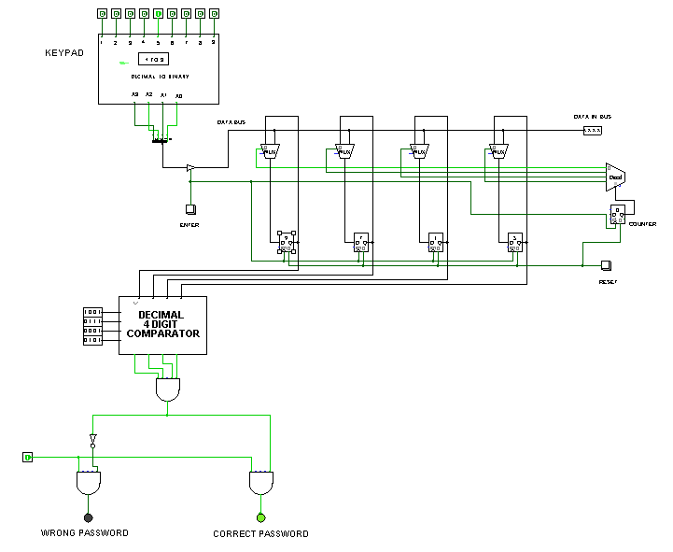

**Let’s understand the project :**

Given below is the overall flowchart of how this system works :

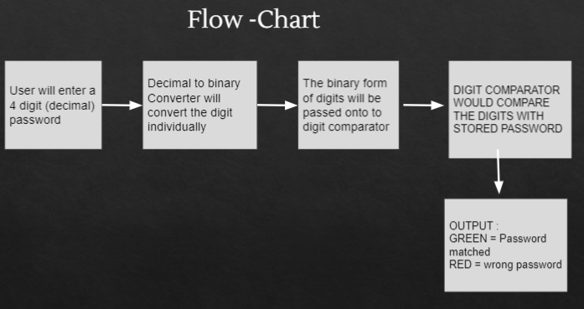

* **The project can be divided into 2 main components which are as follows:**

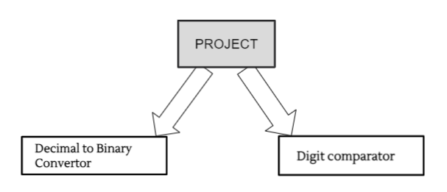

1. **DECIMAL TO BINARY CONVERTER(SINGLE DECIMAL DIGIT)**

This component will convert the 1 digit decimal number(0-9) into its corresponding 4 bit binary number(bcd).

* To convert a decimal number into binary we have used a Decimal to BCD Encoder.

*The truth table of Decimal to BCD encoder is given below :*

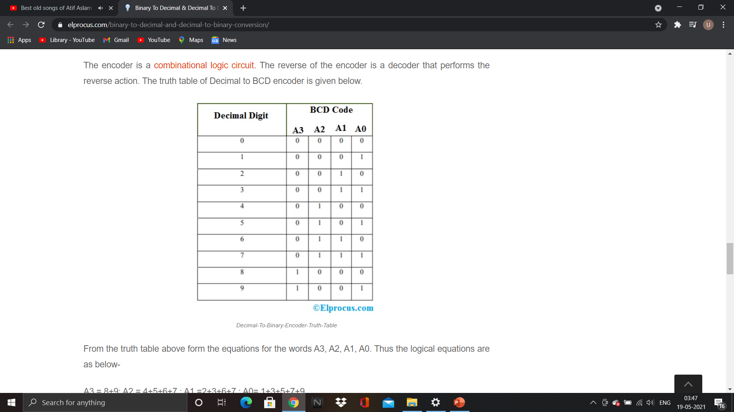

From the truth table above form the equations for the words A3, A2, A1, A0. Thus the logical equations are as below-

A3 = 8+9: A2 = 4+5+6+7 :

A1 =2+3+6+7 : A0= 1+3+5+7+9

Using the above information we can make the following circuit :

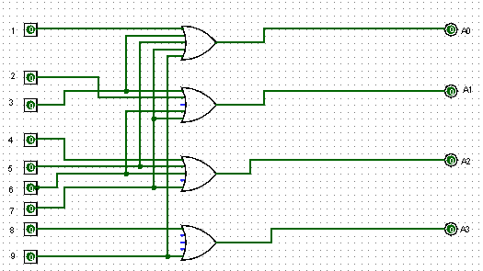

We have made the sub-circuit of the above encoder as given below.We have made use of this sub-circuit in the main system.

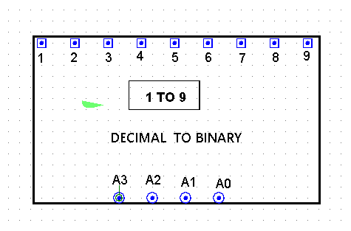

This is a single digit converter , we will use four of these to get 4 decimal and convert them to their corresponding bcd and send to bit comparator.

1. **4 bit comparator**

* The idea of this system is that the 4 switches “Key Code Switches” acts as holding the correct password for unlocking the lock.
* On the other hand, the other 4 switches “Data Entry Switches” acts as data entry points where the code is to be entered to open the lock.
* The “Key Code Switches” have static value and is hidden from the person who is trying to open the lock.

Main Concept : Application of XOR gate

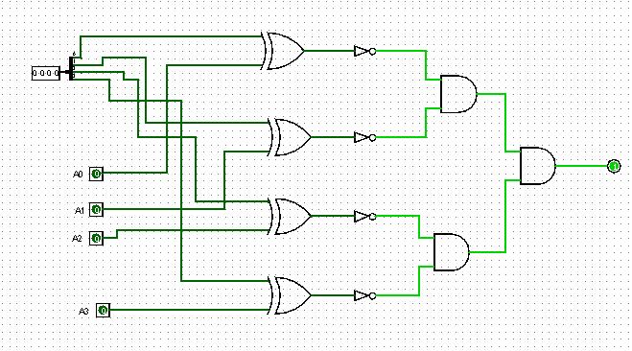

**Note :** *Now since this circuit can only compare a single digit (why ? because a single decimal digit(0-9) can be represented by 4 bits and the above is a 4 bit comparator) so we are going to use 4 such bit comparator to store a 4 digit decimal number ( 1 digit in each comparator) and compare it with each digit coming from each corresponding decimal to binary converter.*

Sub-circuit of above circuit. This sub-circuit is used in our main circuit :

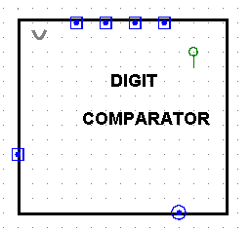

**A simple final implementation after using the above two main components is given below :**

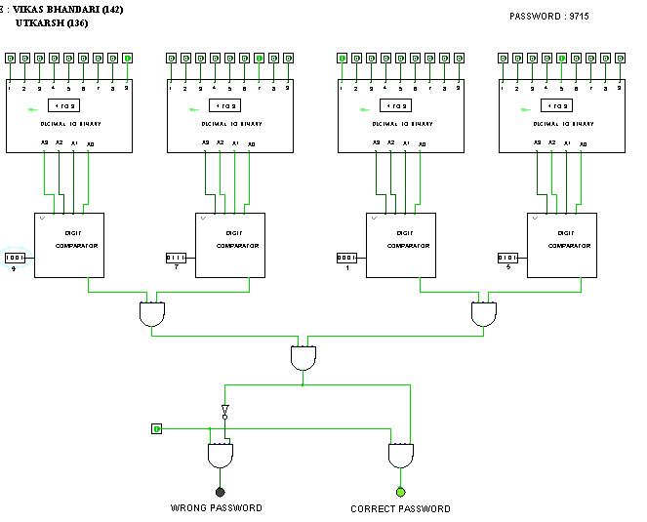

**You can observe following points in the above figure :**

* Our password is 9715, and we have saved each digit in each digit comparator.For example 9 is saved on the most left digit comparator .
* The first layer is of 4 decimal to binary converter which take 4 digits from user convert it into its corresponding bcd and pass on those to corresponding bit comparator.
* The bit comparator compares and gives 1 if it mathes and 0 if not.All the outputs from the comparators goes through And gate and gives the required result as we can see in figures also.

**Note :***The above given circuit is the basic circuit of our project we further made some changes in the project to reduce cost and improve performance.*

**1st improvement :**

We combined all the bit comparator in a single circuit so that it would act as a single 4 digit comparator instead of 4- 4-bit comparator. Below is the circuit implementation .

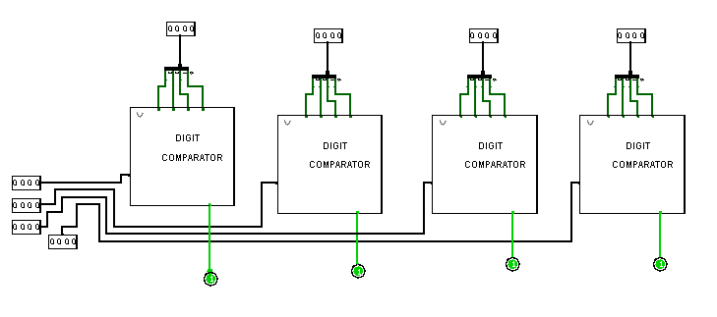

We used the sub-cicuit of the above circuit in our improved version of project :

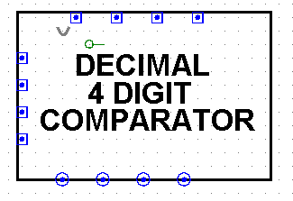

**Main circuit after this improvement looked like this :**

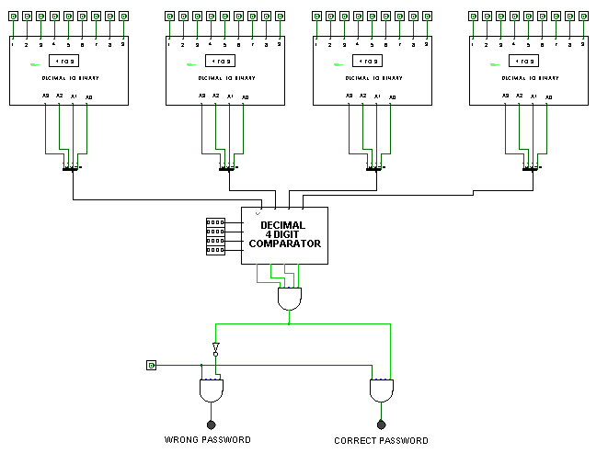

**Improvement 2 .**

-> Now since we were still using four decimal to binary converters in our system but practically there should be only one keypad through which user should all the four digit to check password . So we thought of a way to implement this with the help of :

* A common data bus
* 4 registers
* 4 2*1 MUX
* 2 bit counter
* 2 to 4 Decoder
* A Enter button
* A reset button

**Here is our final circuit after making the changes by adding above stated components in our main circuit :**

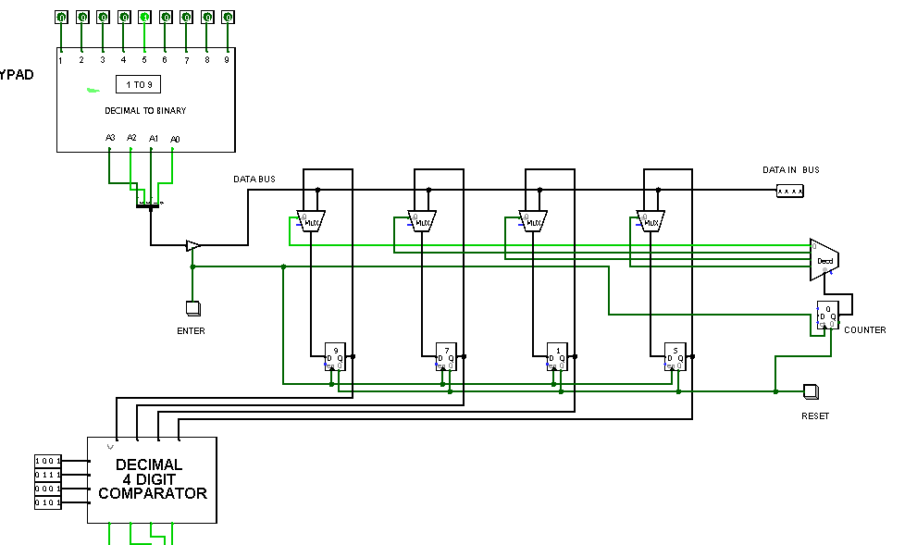

**Concept :**

* To enter a digit , we will enter each digit individually in converter and press enter for each digit so that the digit gets stored in a register as shown above which will be selected with the help of a decoder and counter .
* The above process needs to be repeated 3 more times to store other 3 digits of password .
* After storing the digits now the system compares password and gives output.
* There is a reset button also which we can use to reset system to initial state.

**Working :**

* After entering a single digit , when we press enter button then since enter button is connected to controlled buffer ,clock of registers and counter. It affect each one in following way :   
  1. **Controlled buffer :**On press enter ,it enables the controlled buffer so that bcd of the digit can be mounted on the common data bus.  
  2. **Clock of register :** On pressing enter ,there is high level triggering of the registers due to which the selected registers stores the data that is present in the common data bus.  
  3.**Counter** : On pressing enter , the counter gets increment using negative edge triggering,therfore points to next register where next digit needs to be stored.
* The output of the counter is connected to the select input lines of decoder which helps in selecting the register for storing value from the data bus.
* After all the digits are inserted, the system passes those values to the 4 digit comparator and compares the password and gives the corresponding output .

Link to project :

**Final circuit looks like this :**



**THE END !!!**